Pavement Geometric Tester
Model: TBTGPDS-2

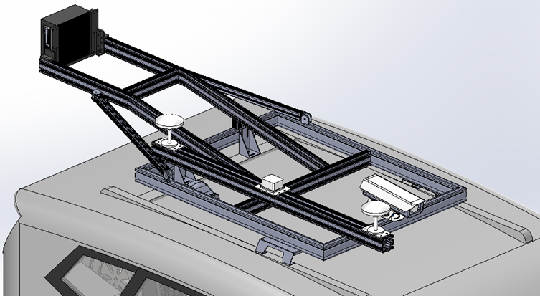
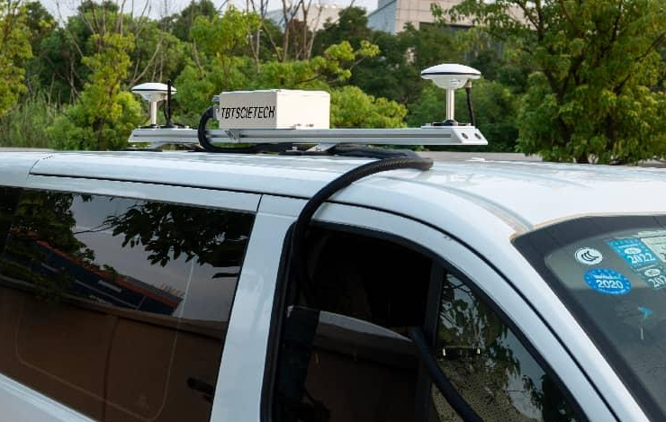

老于
260302

- Introduction
TBTGPDS-2 adopts geometric data testing system to evaluate the geometric shape of the road.
It can continuously collect the data of horizontal slope, vertical slope, and route curvature radius (horizontal curve radius, vertical curve radius) of the road surface.
TBTGPDS-2 detects the inclination angle of horizontal slope, vertical slope and curvature radius of the road surface in real-time, using a combined navigation module which is composed of accelerometer and IMU inertial measurement unit.
TBTGPDS-2 can detect the road surface automatically and fast for long distance via the normal vehicle speed.

- Function
- Provide rapid and accurate basic data collection for any level database; Consummate the linear data on the road network quickly;
- Provide data collection for old road assessment and road network planning;
- Provide reliable reference for research of road geometry index, evaluation of highway service level and limit speed on bends;
- Provide data analysis for construction acceptance and quality control.

- Features
- The high precision compact integrated navigation system can provide continuous high precision position, speed and attitude navigation information in the urban canyon, with higher fixed rate and robustness;
- Adopt the whole system full frequency GNSS baseband board and 6 axis tactical level IMU;
- Real-time acquisite, display and store the data of road surface in the same program interface;
- Continuous and uninterrupted and no mileage limit detection; Real-time data saving; Data format supports Excel;
- Ethernet and laptop make the test more convenient;
- Dynamic performance of the vehicle can’t affect the test result, even with a wide range of changes in speed (0˜120km/h).

- Technical Specification
Test item | Horizontal slope, vertical slope, route curvature radius
Combined navigation | Update frequency | 100Hz
Combined navigation | Angular accuracy of horizontal and vertical slope | 0.1°
Combined navigation | Measuring range of horizontal slope | ± 90°
Combined navigation | Measuring range of vertical slope | ± 90°
Combined navigation | Angular accuracy of course angle | 0.1°
Combined navigation | Measuring range of horizontal curve radius | ≤ 20000m
Combined navigation | Measuring range of vertical curve radius | ≤ 20000m
Combined navigation | Baseline length of the dual antenna | ≥ 1.5m
Communication mode | Ethernet
Range sensor | Pulse count | 2048p/r
Range sensor | IP rating | Ip54
Range sensor | Measuring accuracy | ±0.5m/km
Sampling interval | ≥1m
Data output interval | 10m
Test speed | 0~120km/h

- Work Principle
TBTGPDS-2 applies inertial measurement technology to detect the horizontal slope, vertical slope, and curvature radius (horizontal curve radius, vertical curve radius) of the road surface.

It is mainly composed of combined navigation system, longitudinal distance sensor and computer processing system, it works as shown in the following figure:
Longitudinal Distance Sensor

Combined Navigation
Geometric Computer Processing System
Data Output

- Software Interface
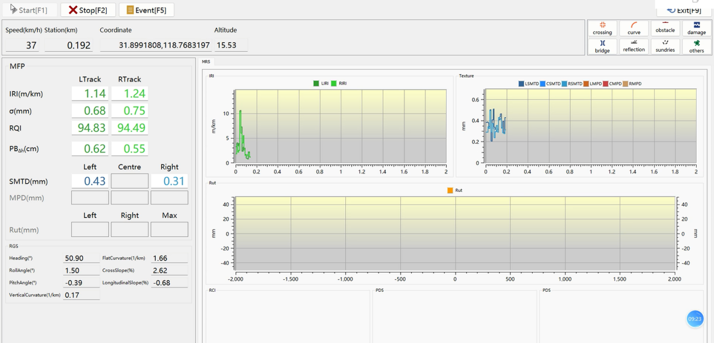

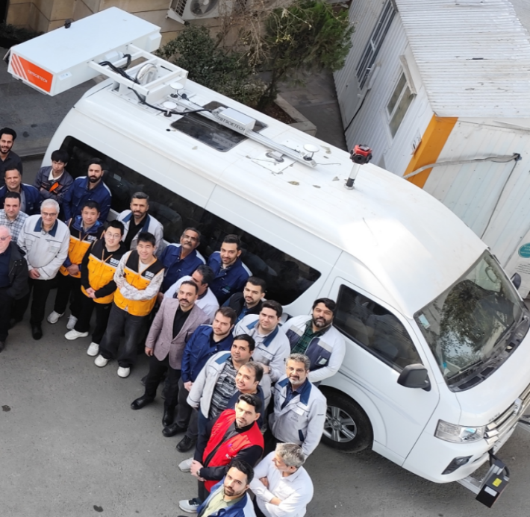
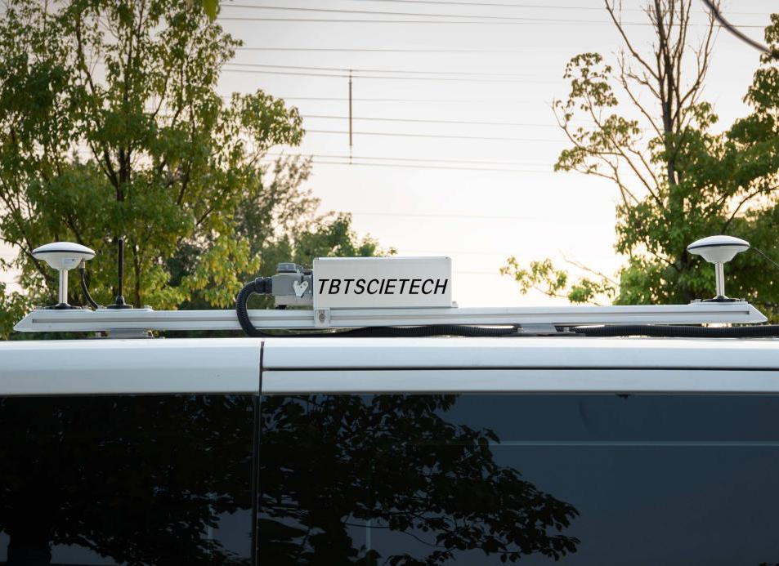
- Real Pictures for Reference

