Light Weight Deflectometer (LWD)
Model: TBTLWD-1G/1GW

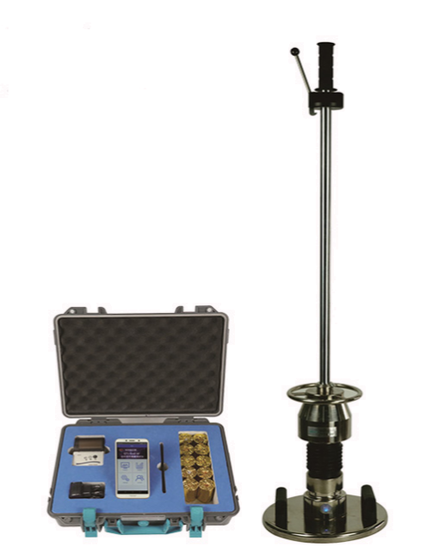
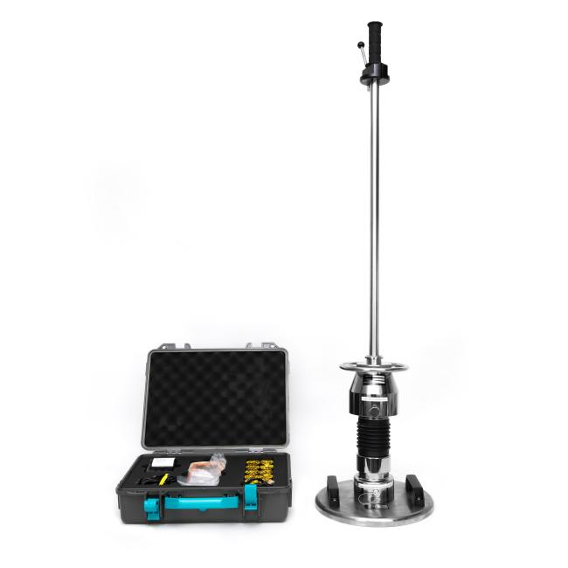

老于
260505

TBTLWD-1G (Wire Type) TBTLWD-1GW (Wireless Type)
- Introduction
TBTLWD series Light Weight Deflectometer is a non-destructive(NDT) instruments, also called as dynamic deformation modulus tester (hand-held drop hammer deflection meter), it is used to determine the deflection capacity of the sub-grade under the dynamic load, thereby evaluating the bearing capacity and deformation of the sub-grade. It is applicable to the monitoring and inspection of foundation construction quality of railways, highways, airports, urban traffic, ports, terminals and industrial and civil buildings subjected to dynamic loads.
It is especially suitable for the detection of narrow sections of the site, such as the transition of roads and bridges (culverts) and the detection of shoulders, both line base and so on. It can quickly measure the dynamic deformation modulus EVD value.

- Referring Standard
ASTM E2835, ASTM E2583

- Features
- Imported sensors and some components are used for high test accuracy;
- Use smart terminal to control test, which realize the wireless data collecting(TBTLWD-1GW only);
- Easy operating, fast testing which make one point test consumes 35s;
- The EVD value is automatically calculated and the curve is displayed, which is accurate and intuitive;
- Handheld main unit with Bluetooth micro-printer, direct printing on site to ensure objective test results;
- USB transmission interface, easy to connect with the computer;
- This instrument simulates the impact of the train on the subgrade when driving at high speed;
- Compared with the static load test, it can reflect the actual stress of the subgrade soil.

- Technical Specification
Usage range | Soil type | Various types of soil and earth and rock mixed fillers with a particle size not larger than 1/4 of the diameter of the load plate
Usage range | Range | 10Mpa≤Evd≤225Mpa
Usage range | Depth | 0~500mm
Usage range | Working environment | Temperature: -10℃~40℃ | Humidity: <90%RH
Data acquisition device | Adding load method | With 1pc geophone sensor  Weight: 15kg, including hammer of 10kg  drop weight drop value: 700±20mm  Maximum impact: 7.07kN  Impact duration: 18±1ms
Data acquisition device | Loading plate | Weight: 15kg  Diameter: 300mm  Thickness: 20mm
Handheld  main unit | Deflection range | 0.10mm~2.00mm
Handheld  main unit | Capacity | 2000 groups of data (TBTLWD-1G)  Refer to cell phone config, normally with 10G storage(TBTLWD-1GW)
Handheld  main unit | Screen size | 3inches (TBTLWD-1G) / 5 inch(TBTLWD-1GW)
Handheld  main unit | Power supply | Li-battery of more than 18hours(TBTLWD-1G)  According to cell phone battery(TBTLWD-1GW)
Handheld  main unit | Display | Screen display (English)--TBTLWD-1G  Cell phone app (English)--TBTLWD-1GW
Handheld  main unit | Data transfer | Cable transfer (TBTLWD-1G)  Wifi transfer data (TBTLWD-1GW)
Printer | Connection | Bluetooth
Package | Carrying case | Inside case material: engineering plastic  measurement: around 420×140×335mm  Weight: around 4.5kg
Package | Carrying case | Outside case material: aluminum alloy case  Measurement: around 1230×400×400mm  Weight: around 56kg

- Standard Configure
No. | Item | Standard/Optional | Quantity
1 | Main Host | Standard | 1pc
2 | Controller | Standard | 1pc
3 | Printer with print paper | Standard | 1pc
4 | Charger | Standard | 1pc
5 | Instruction Manual | Standard | 1pc
6 | Carrying Case | Standard | 2pcs
7 | Portable Trolley | Optional | 1pc

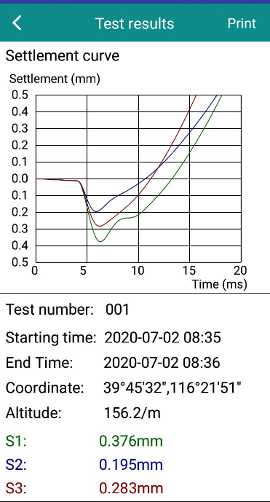
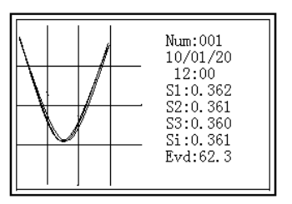
- Software Interface

Displayer of TBTLWD-1G
Displayer of TBTLWD-1GW
- Real Pictures for Reference
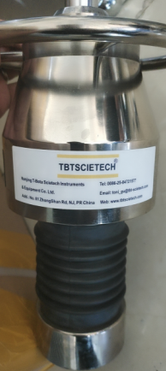
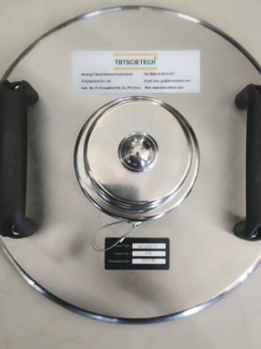

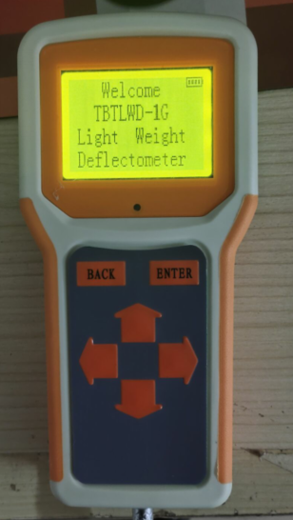
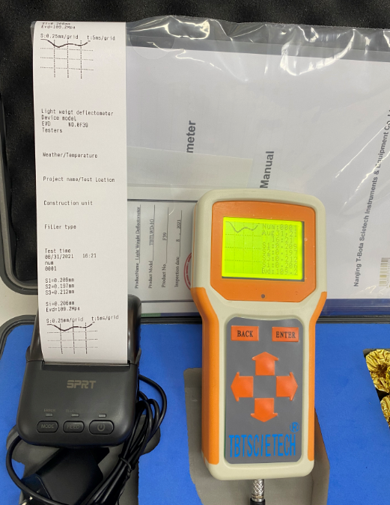
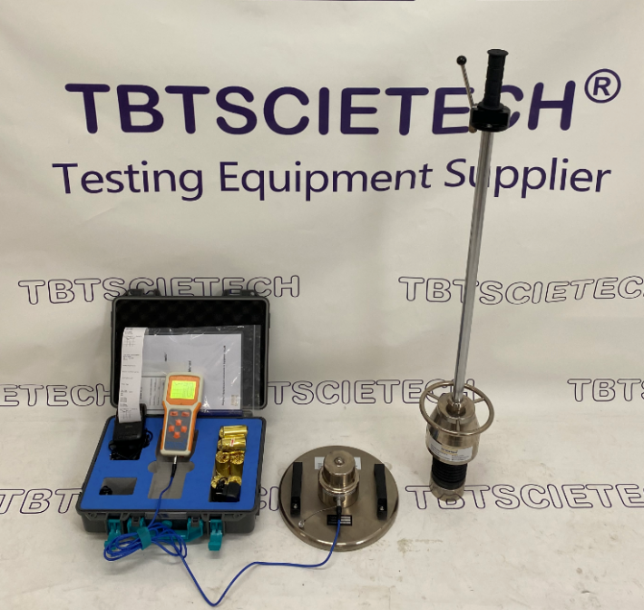

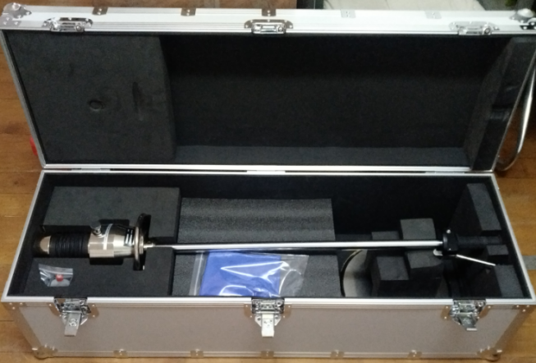
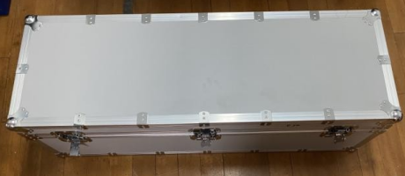

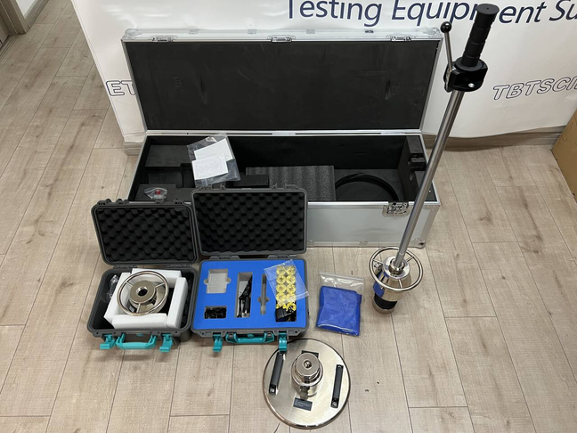
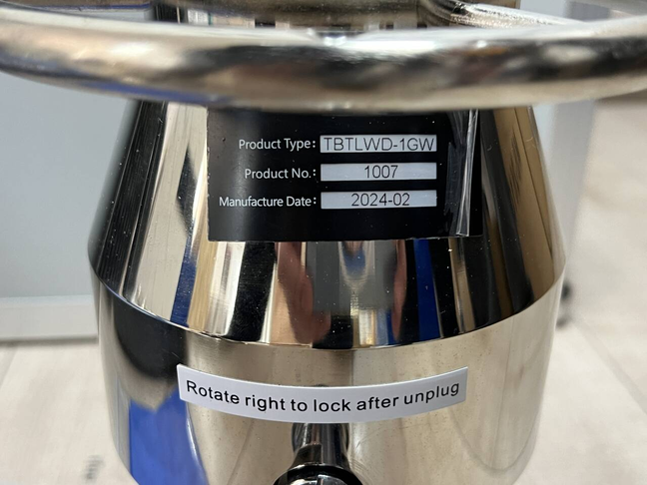

- Calibration and Testing for TBTLWD
